Jawaban SQL Practice

2. Show the last name, job, salary, and commission of those employees who earn commission. Sort the data by the salary in descending order.

jawaban :

select
e.last_name,
j.job_title as job,
e.salary,
e.commission_pct from
employees e,
jobs j
where e.job_id = j.job_id and e.COMMISSION_PCT is not null order by e.SALARY desc;

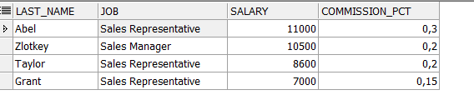
3. Show the employees that have no commission with a 10% raise in their salary (round off the salaries).
jawaban :
select
e.*,
round((e.salary * 0.1) + e.salary) as TEN_PERCENT_RAISE_SALARY
from employees e
where e.COMMISSION_PCT is null;

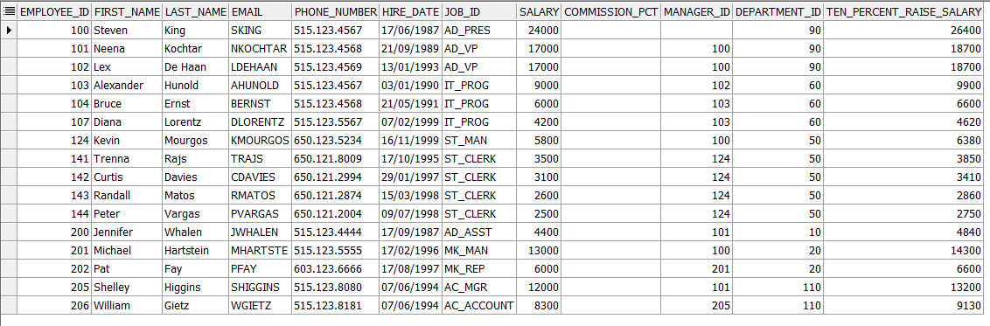

4. Show the last names of all employees together with the number of years and the number of completed months that they have been employed.
jawaban :
select
emp.last_name,
floor((sysdate-emp.hire_date)/365) "YEARS",
floor(mod(floor(sysdate-emp.hire_date),365)/30) "MONTHS"
from employees emp;

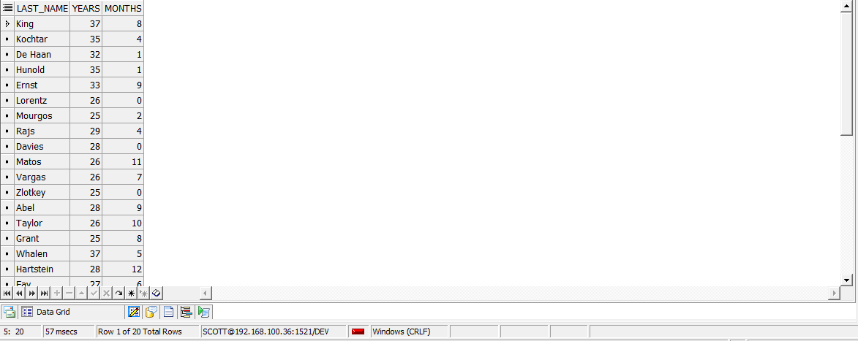
5. Show those employees that have a name starting with J, K, L, or M.
jawaban :
select *
from
employees e
where
e.first_name LIKE 'J%'
or
e.first_name LIKE 'K%'
or
e.first_name LIKE 'L%'
or
e.first_name LIKE 'M%'

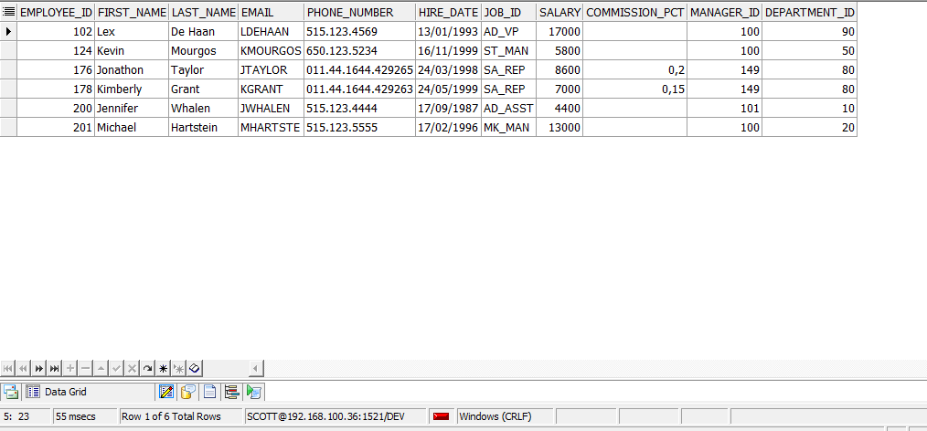
6. Show all employees, and indicate with “Yes” or “No” whether they receive a commission.
jawaban :
select e.*, nvl2(e.COMMISSION_PCT, 'YES', 'NO') as is_receive_commission from employees e

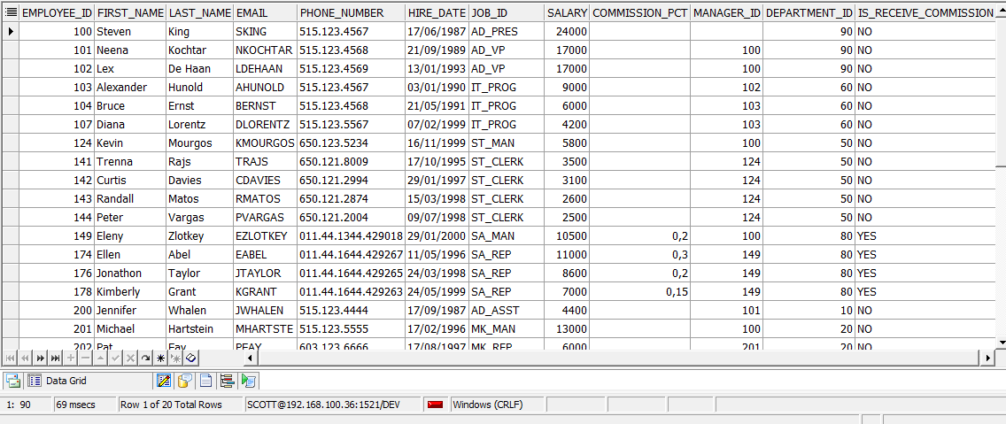
7. Show the department names, locations, names, job titles, and salaries of employees who work in location 1800.
jawaban :
select d.department_name,(l.street_address || ', ' || l.CITY || ', ' || l.STATE_PROVINCE || ', '
|| l.COUNTRY_ID) as location,j.job_title,(e.first_name) || ' ' || (e.last_name) as name,
e.salary from employees e join departments d on e.department_id = d.department_id join locations l
on l.location_id = d.location_id join jobs j on j.job_id = e.job_id where l.location_id = 1800;

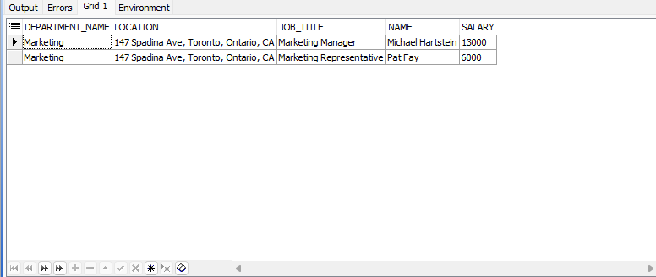
8. How many employees have a last name that ends with an n? Create two possible solutions.
jawaban :
-- solution 1

select count(*) as total_employee_with_ends_with_n
from employees e
where
e.last_name LIKE '%n';

--solution 2

select count(*) as total_employee_with_ends_with_n
from employees e
where
regexp_like(e.last_name, 'n$', 'i');

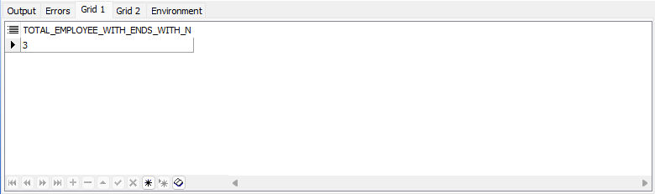
9. Show the names and locations for all departments, and the number of employees working in each department. Make sure that departments without employees are included as well.
jawaban :
select
d.DEPARTMENT_NAME,
(l.street_address
|| ', '
|| l.CITY
|| ', '
|| l.STATE_PROVINCE
|| ', '
|| l.COUNTRY_ID
) as location,
count(e.EMPLOYEE_ID) as total_employees
from
departments d
join locations l
on d.LOCATION_ID = l.LOCATION_ID
left join employees e
on e.DEPARTMENT_ID = d.DEPARTMENT_ID
group by
l.street_address
|| ', '
|| l.CITY
|| ', '
|| l.STATE_PROVINCE
|| ', '
|| l.COUNTRY_ID,
d.DEPARTMENT_NAME,
l.LOCATION_ID

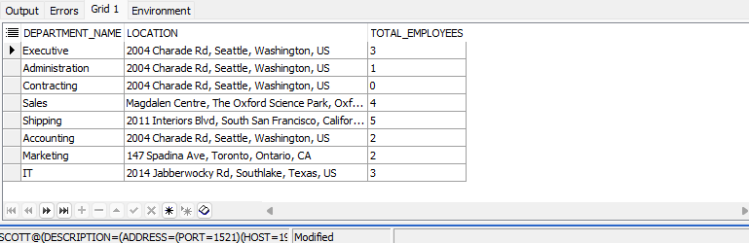
10. Which jobs are found in departments 10 and 20?
jawaban :
select
j.job_title
from
departments d
join employees e
on d.DEPARTMENT_ID = e.DEPARTMENT_ID
join
jobs j
on
e.job_id = j.job_id
where
e.department_id in (10, 20)

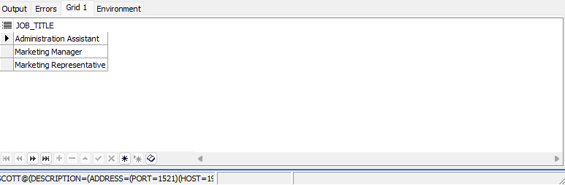

11. Which jobs are found in the Administration and Executive departments, and how many employees do these jobs? Show the job with the highest frequency first.
jawaban :
select
d.DEPARTMENT_NAME,
j.JOB_TITLE,
count(e.EMPLOYEE_ID) as total_employee_do_this_job
from
departments d
join employees e
on d.DEPARTMENT_ID = e.DEPARTMENT_ID
join jobs j
on j.JOB_ID = e.JOB_ID
where
d.DEPARTMENT_ID in (10, 90)
group by
d.DEPARTMENT_NAME,
j.JOB_TITLE

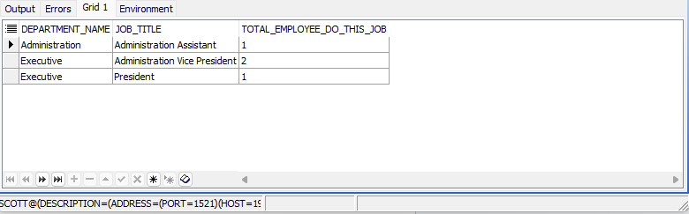
12. Show all employees who were hired in the first half of the month (before the 16th of the month).
jawaban :
select *
from employees e
where EXTRACT(day from e.hire_date) < 16;

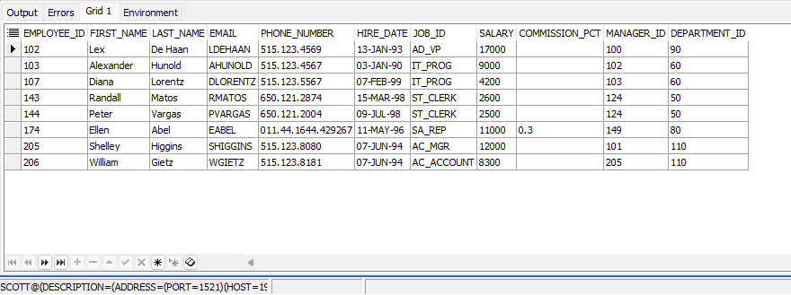
13. Show the names, salaries, and the number of dollars (in thousands) that all employees earn.
jawaban :

select
(e.FIRST_NAME || ' ' || e.LAST_NAME) as Name,
e.SALARY,
e.SALARY / 1000 as salary_in_thousand
from
employees e;

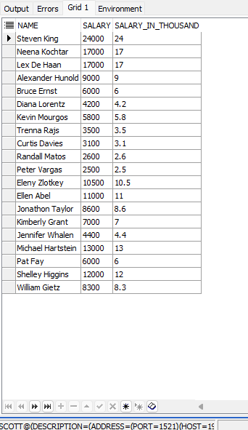

14. Show all employees who have managers with a salary higher than $ 15,000. Show the following data: employee name, manager name, manager salary, and salary grade of the manager.
jawaban :
select
e.FIRST_NAME || ' ' || e.LAST_NAME as EMPLOYEE_NAME,
m.FIRST_NAME || ' ' || m.LAST_NAME as MANAGER_NAME,
m.SALARY as MANAGER_SALARY,
jg.GRADE_LEVEL as MANAGER_GRADE
from employees e
join employees m on e.MANAGER_ID = m.EMPLOYEE_ID
join job_grades jg on m.SALARY between jg.LOWEST_SALARY and jg.HIGHEST_SALARY
where m.salary > 15000;
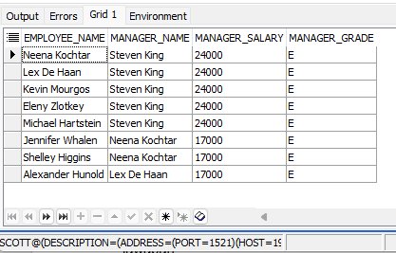
15. Show the department number, name, number of employees, and average salary of all departments, together with the names, salaries, and jobs of the employees working in each department.
Jawaban :
select
e.first_name || ' ' || e.last_name as name,
e.salary,
e.job_id,
d.department_id as department_number,
d.department_name as department_name,
count(e.employee_id) over (partition by d.department_id) as total_employee,
avg(e.salary) over (partition by d.department_id) as "salary_average"
from employees e
right join departments d on e.department_id = d.department_id
order by d.department_id, e.salary desc;

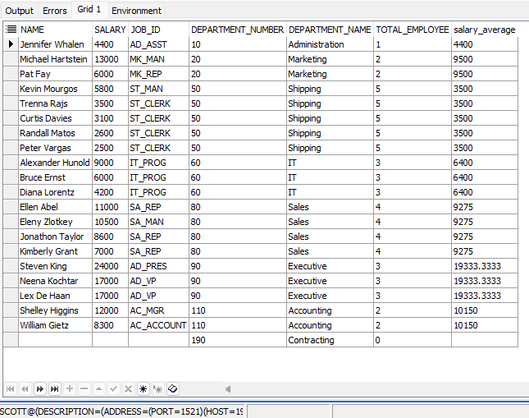
16. Show the department number and the lowest salary of the department with the highest average salary.
Jawaban :
with DepartmentSalaries as (
select
department_id,
avg(salary) as avg_salary,
min(SALARY) as min_salary
from
employees
group by
department_id
),
MaxAvgSalaryDept as (
select
department_id,
avg_salary,
min_salary
from
DepartmentSalaries
where
avg_salary = (select max(avg_salary) from DepartmentSalaries)
)
select
department_id,
avg_salary,
min_salary
from
MaxAvgSalaryDept;

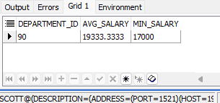
17. Show the department numbers, names, and locations of the departments where no sales representatives work.
select d.DEPARTMENT_ID, d.DEPARTMENT_NAME, l.STREET_ADDRESS
from departments d
join employees e
on d.DEPARTMENT_ID = e.DEPARTMENT_ID
join jobs j
on j.JOB_ID = e.JOB_ID
join locations l
on l.LOCATION_ID = d.LOCATION_ID
where
j.JOB_TITLE != 'Sales Representative'
group by d.DEPARTMENT_ID, d.DEPARTMENT_NAME, l.STREET_ADDRESS;

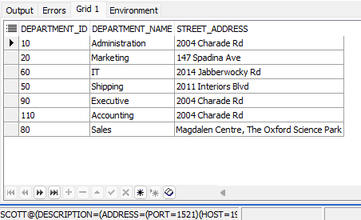
18. Show the department number, department name, and the number of employees working in each department that :
a. Includes fewer than 3 employees.
b. Has the highest number of employees.
c. Has the lowest number of employees.
jawaban :
a. select
d.department_id as nomor_department,
d.department_name as nama_department,
count(e.employee_id) as jumlah_pegawai
from departments d
left join employees e on d.department_id = e.department_id
group by d.department_id, d.department_name
having count(e.employee_id) < 3
order by jumlah_pegawai;

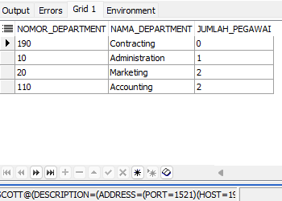

b. select
d.department_id as nomor_department,
d.department_name as nama_department,
count(e.employee_id) as jumlah_pegawai
from departments d
left join employees e on d.department_id = e.department_id
group by d.department_id, d.department_name
order by jumlah_pegawai desc
fetch first 1 row only;

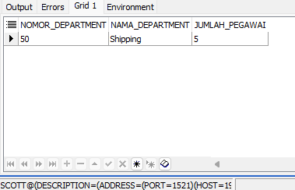

c. select
d.department_id as nomor_department,
d.department_name as nama_department,
count(e.employee_id) as jumlah_pegawai
from departments d
left join employees e on d.department_id = e.department_id
group by d.department_id, d.department_name
order by jumlah_pegawai asc
fetch first 1 row only;

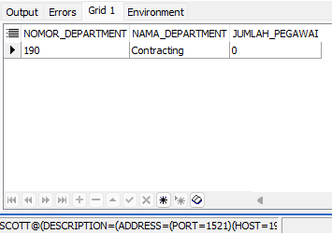

`

19. Show the employee number, last name, salary, department number, and the average salary in their department for all employees

select e.employee_id,
e.last_name,
e.salary,
e.department_id,
avg(e.salary) over (partition by e.department_id) as avg_salary_in_department
from employees e
order by e.salary asc;

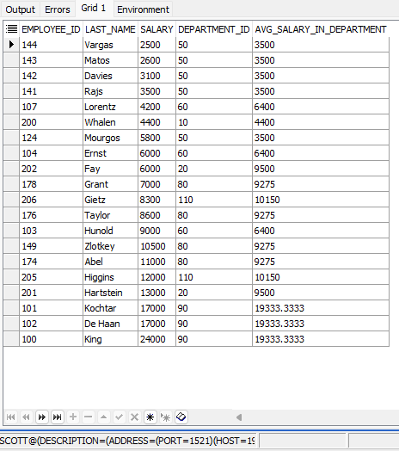

20. Show all employees who were hired on the day of the week on which the highest number of employees were hired
Jawaban :
select e.employee_id,
e.last_name,
e.hire_date,
to_char(e.hire_date, 'day') as hire_day
from employees e
where to_char(e.hire_date, 'day') = (
select to_char(e1.hire_date, 'day')
from employees e1
group by to_char(e1.hire_date, 'day')
order by count(e1.employee_id) desc
fetch first 1 rows only
);

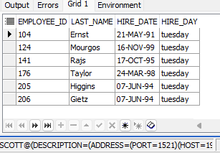
21. Create an anniversary overview based on the hire date of the employees. Sort the anniversaries in ascending order
Jawaban :
select e.employee_id,
e.last_name,
floor((sysdate - e.hire_date)/365) as anniversary
from employees e
order by to_char(e.hire_date, 'MM-DD');

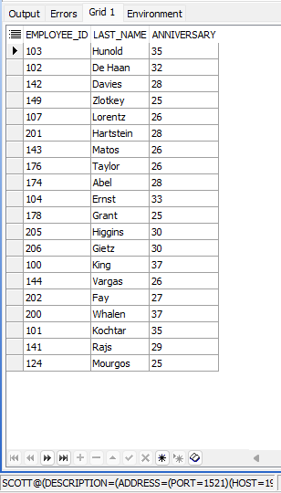
22.1 Fungsi untuk mengetahui minus atau tidaknya suatu angka Inputan : -20 Output : -1
Jawaban :
CREATE OR REPLACE FUNCTION XTD_SQLPRAC_IS_MINUS_FNC(p_input NUMBER)
RETURN NUMBER IS
BEGIN
RETURN SIGN(p_input);
END;
/
22.2 Fungsi untuk memaksakan panjang dari suatu karakter , walaupun inputan kurang dari karakter tersebut. Inputan : 1 Output : 000001 atau 100000
CREATE OR REPLACE FUNCTION XTD_SQLPRAC_PADD_FNC(
p_input VARCHAR2,
p_length NUMBER,
p_position VARCHAR2
) RETURN VARCHAR2 IS
v_result VARCHAR2(100);
BEGIN
IF p_position = 'LEFT' THEN
v_result := LPAD(p_input, p_length, '0');
ELSIF p_position = 'RIGHT' THEN
v_result := RPAD(p_input, p_length, '0');
ELSE
v_result := p_input;
END IF;

RETURN v_result;
END;
/

22. test case
select
XTD_SQLPRAC_IS_MINUS_FNC(20) as test_is_minus_func_,
XTD_SQLPRAC_IS_MINUS_FNC(-20) as test_is_minus_func_2,
XTD_SQLPRAC_PADD_FNC(1, 6, 'LEFT') as test_padd_left_func_1,
XTD_SQLPRAC_PADD_FNC(1, 6, 'RIGHT') AS test_padd_right_func_1,
XTD_SQLPRAC_PADD_FNC(111, 6, 'LEFT') as test_padd_left_func_2,
XTD_SQLPRAC_PADD_FNC(111, 6, 'RIGHT') AS test_padd_right_func_2
from dual;

23. 1 Fungsi untuk mengambil format jam dari inputan date inputan : ’20-AUG-2006 10:30: output : 10
Jawaban :
FUNCTION XTD_SQLPRAC_GET_HOUR_FNC(
p_input VARCHAR2) RETURN NUMBER IS
v_temp_date DATE;
v_hour VARCHAR2(10);
BEGIN
v_temp_date := TO_DATE(p_input, 'DD-MON-YYYY HH24:MI:SS');
v_hour := to_char(v_temp_date, 'HH24');
RETURN TO_NUMBER(v_hour);
END;

23.2 Fungsi untuk menghapus spasi dari suatu statement yang mengandung spasi inputan : ‘Coba ‘output : ‘Coba’
FUNCTION XTD_SQLPRAC_RWS_FNC(
p_input VARCHAR2
) RETURN VARCHAR2 IS
BEGIN
RETURN REPLACE(p_input, ' ', '');
END;
/

23. test case
select
XTD_SQLPRAC_GET_HOUR_FNC('20-AUG-2025 12:30:31') as test_hour_1,
XTD_SQLPRAC_RWS_FNC('Coba ') as test_no_white_space_1,
XTD_SQLPRAC_GET_HOUR_FNC('20-AUG-2021 09:30:31') as test_hour_2,
XTD_SQLPRAC_RWS_FNC(' Test') as test_no_white_space_2
from dual;

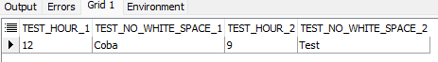

24.1 Fungsi untuk membesarkan semua huruf dalam suatu statement inputan : ‘abc’ output : ‘ABC’
FUNCTION XTD_SQLPRAC_W_UPPER_FNC(
p_input VARCHAR2
) RETURN VARCHAR2 IS
BEGIN
RETURN UPPER(p_input);
END;

24.2 Fungsi untuk membulatkan ke bawah inputan decimal inputan : 1.1 output : 1
CREATE OR REPLACE FUNCTION XTD_SQLPRAC_ROUND_DOWN_FNC(
p_input NUMBER
) RETURN NUMBER IS
BEGIN
RETURN FLOOR(p_input);
END;
/

24. test case
select
XTD_SQLPRAC_W_UPPER_FNC('abc') as test_words_upper_1,
XTD_SQLPRAC_ROUND_DOWN_FNC(1.1) as test_num_round_down_1,
XTD_SQLPRAC_W_UPPER_FNC('fahmi') as test_words_upper_2,
XTD_SQLPRAC_ROUND_DOWN_FNC(1.4) as test_num_round_down_2
from
dual
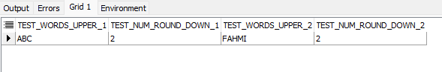

25.1 Fungsi untuk membuat statement berformat berikut : inputan : ABC output : Abc
Jawaban :
CREATE OR REPLACE FUNCTION XTD_SQLPRAC_W1_LOWER_FNC(
p_input VARCHAR2
) RETURN VARCHAR2 IS
v_output VARCHAR2(100);
BEGIN
IF p_input IS NULL THEN
RETURN NULL;
END IF;

v_output := UPPER(SUBSTR(p_input, 1, 1)) || LOWER(SUBSTR(p_input, 2));

RETURN v_output;
END;
/

25.2 Fungsi untuk pembulatan ke atas untuk inputan number : inputan : 1.1 output : 2
Jawaban :
CREATE OR REPLACE FUNCTION XTD_SQLPRAC_ROUND_DOWN_FNC(
p_input NUMBER
) RETURN NUMBER IS
BEGIN
RETURN CEIL(p_input);
END;
/

25 test case :
select
XTD_SQLPRAC_W1_LOWER_FNC('ABC') as test_words_lower_1,
XTD_SQLPRAC_ROUND_DOWN_FNC(1.1) as test_num_round_up_1,
XTD_SQLPRAC_W1_LOWER_FNC('FAHMIIIIII') as test_words_lower_1,
XTD_SQLPRAC_ROUND_DOWN_FNC(1.02) as test_num_round_up_1
from dual;

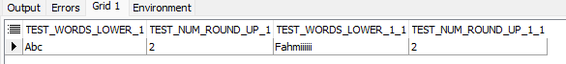

27.1 Fungsi untuk memaksakan apapun inputan dari number selalu jadi positif Input : -200 Output : 200
Jawaban :
CREATE OR REPLACE FUNCTION XTD_SQLPRAC_ALWAYS_POSITIVE_FNC(
p_input NUMBER
) RETURN NUMBER IS
BEGIN
RETURN ABS(p_input);
END;
/

27.2 Fungsi untuk membuat statement berformat berikut : inputan : ABC output : abc
Jawaban :
CREATE OR REPLACE FUNCTION XTD_SQLPRAC_WORDS_LOWER_FNC(
p_input VARCHAR2
) RETURN VARCHAR2 IS
BEGIN
RETURN LOWER(p_input);
END;
/

27. test case
select
XTD_SQLPRAC_ALWAYS_POSITIVE_FNC(-200) as test_always_positive_1,
XTD_SQLPRAC_WORDS_LOWER_FNC('ABC') as test_words_lower_1
from
dual;

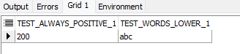

28.1 Fungsi untuk mengetahui jumlah bulan antara dua buah tanggal input : 20-JAN-2006 dan 20 –AUG-2006 output : 7
Jawaban :
CREATE OR REPLACE FUNCTION XTD_SQLPRAC_MONTH_DIFFERENCE_FNC(
p_start_date VARCHAR2,
p_end_date VARCHAR2
) RETURN NUMBER IS
v_to_date_start DATE;
v_to_date_end DATE;
v_date_month_start NUMBER;
v_date_month_end NUMBER;
BEGIN
v_to_date_start := TO_DATE(p_start_date, 'DD-MON-YYYY');
v_to_date_end := TO_DATE(p_end_date, 'DD-MON-YYYY');

v_date_month_start := EXTRACT(MONTH FROM v_to_date_start);
v_date_month_end := EXTRACT(MONTH FROM v_to_date_end);

RETURN v_date_month_end - v_date_month_start;
END;
/

28. test case :
select
XTD_SQLPRAC_MONTH_DIFFERENCE_FNC('20-JAN-2006', '20ûAUG-2006') as test_date_difference_1,
XTD_SQLPRAC_MONTH_DIFFERENCE_FNC('20-JAN-2006', '20ûDEC-2007') as test_date_difference_2
from
dual;

